Save Electricity

Project proposal – An educational android game

By Suraj Dangwal, Kunal Prakash

2018

Table of Contents

List of Tables 4

**EXECUTIVE SUMMARY** 5

**1.Introduction** 6

**1.2 Issue** 6

**1.3 Purpose** 7

**1.4 Scope** 7

**1.5 Aim & Objectives** 7

**1.6 Measurable organisational Value** 8

**1.7 Stakeholders: who will benefit it, impact?** 9

**1.8 Research Question** 9

**2. Literature Review** 10

**2.1 Save the Power!** 10

**2.2 Defenders of Nature - Games from YovoGames!** 11

**2.3 Nature Warrior – Akshay Jhadav** 12

**2.4 Save Water – Warmodroid** 13

**2.5 Protect the Tree – MoonBear LTD** 14

**2.6 Garden Games for Kids – Miniclub by Bubadu** 15

**2.7 Jungle Doctor – Libii** 16

**2.8 Save Water and Earth - YoguruTechnologies** 17

**2.9 Comparison Table** 18

**2.10 Discussion & Conclusion** 19

**2.11 Summary** 21

**3. Software Methodology: SDLC Spiral Model** 23

**3.1 Why Spiral model?** 23

**3.2 Spiral Model Diagram** 23

**3.3 How we will use this Model?** 24

**4. Game Design & Analysis** 26

**4.1 Game Menu** 26

**4.2 PLAY GAME – LEVEL 1** 27

**4.3 Example 1 preview** 28

**4.4 Example 2 Preview** 28

**4.5 TOUCH INTERACTION FLOWCHART** 29

**4.6 PROGRESSING LEVEL FLOWCHART** 30

**4.7 Overview Flowchart** 31

**4.8 USE CASE** 31

**4.9 OVERALL NAVIGATION** 32

**5. Resources Collections** 33

**5.1 Software** 33

**5.1.1 Unity & Unity’s asset Store** 33

**5.1.2 Android Studio** 33

**5.1.3 Visual Studio** 33

**5.1.4 Unreal Engine’s asset store** 34

**5.1.5 Office 365** 34

**5.1.6 WhatsApp** 34

**5.1.7 Adobe Photoshop** 34

**5.1.8 GitHub** 34

**5.1.9 Stack overflow website** 35

**5.2 Hardware** 35

**5.2.1 PC Desktop** 35

**5.2.2 Android Mobile Device** 35

**5.2.3 Flash-drive/USB storage device** 35

**6. Project Risks** 36

**6.1 Eight Weeks Deadline Time** 36

**6.2 Amateur Game developer** 36

**6.3 Time Management/Scheduling** 36

**6.4 Finding assets for the game** 37

**REFERENCES** 38

**Responsibilities** 39

**Gantt Chart – Work Breakdown Structure** 40

LIst of figures

Figure 2 Save the power! (Flavare, 2015) 10

Figure 1 Save the power! (Flavare, 2015) 10

Figure 3 Defender of The Nature (Games from Yovogames !, 2018) 11

Figure 4 Nature Warrior (Akshay Jhadav, 2018) 12

Figure 5 Save Water (Warmodroid, 2015) 13

Figure 6 Protect the Tree (Moonbear LTD, 2016) 14

Figure 7 Garden Game for Kids (Miniclub by Bubadu, 2017) 15

Figure 8 Jungle Doctor (Libii, 2014) 16

Figure 9 Save Water and Earth (YoguruTechnologies, 2015) 17

Figure 10 Spiral Model (Marco, n.d) 23

Figure 11 Design Sketch - Game Menu 26

Figure 12 Design Sketch - Play Game Level 1 27

Figure 13 Bedroom - Daytime Art (Vectorpouch, n.d) 28

Figure 14 Bedroom - Night (Andrey, n.d) 28

Figure 15 Flowchart - Touch Interaction 29

Figure 16 Flowchart - Progressing level 30

Figure 17 Flowchart - Overview 31

Figure 18 Use Case - Children Interaction 31

Figure 19 Overall Navigation 32

Figure 20 Current Progress & Responsibilities 39

Figure 21 Gantt Chart - Work Breakdown Structure 40

# List of Tables

Table 1 - Comparison Table 18

Table 2 - Literature Review: Summary 21

# **EXECUTIVE SUMMARY**

This is our project proposal document that will explain our proposed idea in detail. The documentation will identify the current situation which is a topic about teaching children the concept of saving electricity. We explain the issues that we have and what we propose to do about it. Our idea is to develop an android educational game that will convey the message about saving electricity to children between 4 to 6 years old. We have identified our aims and objectives for the project to properly plan out our requirements. Documentation on how it will have an impact on social, financial and environmental aspects is also provided to emphasize the importance of our project. We also included the stakeholders that will be affected by this project and what our research question is that we would like to answer. In order to get ideas and build an effective and quality educational game for children, we did a literature review of 8 android games that either conveyed the same message or had a similar concept to ours. With the literature review we were able to identify the quality attributes of those kinds of games and the drawbacks that some had which we could build upon or improve. We demonstrate the comparison of the reviewed games in form of tables for simplicity.

For the business model we demonstrate how the SDLC (Software Development Life Cycle) will help us with the use of spiral model. For a better representation of our educational game we have also included design sketches and discussed about it with the necessary details. Following the design sketches, our documentation also provides flowcharts and use cases for better representation of functionalities and how it would work. Lastly, we mentioned what resources we will use for both software and hardware, the identified project risks throughout our project and Gantt chart to show our project’s deadline time.

# **1.Introduction**

Electricity is one of the key-resource of modern society. It plays a major role in household activities, school, colleges, industries and many more. As we need electricity for most of our work, we tend to consume it more. There are situations when we consume electricity even if it is not required which leads to its wastage. Also, the consumption of electricity is very high, and it keeps increasing.

Most of the countries in the world use natural resources for producing the electricity. High consumption means we must use more resources to produce electricity, which could lead us to a situation of high-power demand and its scarcity in future. Our project is to spread awareness about importance of saving the electricity all over the world. There are countries which use resources like oil and coal to produce electricity. The more amount of electric consumption leads to burning of more amount of coal and oil which is not only bad in terms of natural resource usage, but it is harming the environment as well.

The energy consumption can be reduced significantly if people learn to avoid wasting electricity unnecessarily. Though everyone from children to adults can be a part of the problem, we are focusing mainly on children because we believe that educating children is the best way to convey our message since an educated and responsible child will not only bring awareness within the family, but it will benefit the entire society.

## **1.2 Issue**

Children at very young age are not aware about the importance of saving electricity. There are not many android games available on internet or on google play-store with similar learning experience that can help educate children on this concept.

## **1.3 Purpose**

The opportunity arises for us to develop an educational game that will convey our message to children, since entertainment methods can be more effective and attractive way to motivate children.

## **1.4 Scope**

We have a scope of spreading awareness amongst the children between 4-6 years of age with the help of which they will learn and become more responsible towards saving the electricity. Their decision-making skill will improve. It will also help in reducing the unnecessary consumption or wastage of electricity

## **1.5 Aim & Objectives**

Our aim is to design and develop an educational android game for children between 4-6 years of age that will teach them the concept of saving electricity.

Following are our objectives:

1. **Easy navigation**: The children should be able to navigate easily. This means our game interfaces will be simple to understand. The game menu will have 2 buttons, for playing and exiting the game.
2. **Conduct research on similar games**: This will help us in identifying the factors that are required to create an educational game and also identifying the areas where we can make improvements.
3. **Audio & Visual implementations**: The game will rely heavily on audio and visuals. We will make sure that we create scenarios with attractive visuals for children and include audio in form of voice to help communicate with children which is more effective than texts.
4. **Implement Simple Interface**: Our game will not have too many interfaces to complicate things for children. We will implement a progression bar for determining how close a player is to complete the level. Another interface for 3 failed attempts which means after 3 failed attempts, the game will end and restart automatically.
5. **Different levels**: Different levels will be used to present different scenarios and challenges for children. The levels will somewhat reflect real life situations but in the form of a game.
6. **Interactable objects**: Throughout the game, children as a player will come across different interactable objects which will keep them engaged.
7. **Reward system**: We will implement a simple reward system that will motivate children to continue playing the game.

## **1.6 Measurable organisational Value**

Our project will impact mainly on following areas:

1. Social & Environmental
2. Financial

**Social & Environmental:**

The game will bring awareness amongst children about power consumption. This means our game will encourage and influence children to make wise decision when using electricity. It will benefit the family, schools, governments and society in general.

Environment will be benefited due to reduction in usage of natural resources and it will also help in reducing the pollution caused by burning of oil and coal.

**Financial:**

Reduction in consumption of electricity will generate low cost bills, benefitting the family and businesses. Due to reduction in supply of energy, electricity organizations will make less money.

## **1.7 Stakeholders: who will benefit it, impact?**

Our game will have an impact on 5 main stake holders, they are:

1. **Children**: Children will learn and become responsible. It will improve their decision-making skills.
2. **Parents**: Parents will be happy to see their child becoming responsible at very early age and their house will generate low electricity bill.
3. **Electricity organisations**: Electricity organisations will have to spend less on operational costs. It also means that they will make less money.
4. **Schools**: School will be benefitted by having responsible children.
5. **Government**: Government will have to spend less money and efforts to meet the power needs of the nation.

## **1.8 Research Question**

*Can our educational game influence/teach children the concept of saving electricity?*

This question will help us to figure out whether our game will have the desired impact on children or not. Therefore, we will be focusing on implementing simple interfaces and provide voice assistant to the children throughout the game. Our plan is to develop the game including specified objectives within the given timeframe and meet the research requirements.

# **2. Literature Review**

In this Literature Review section, we will analyse 8 android games that are similar to our concept. This will help us identify the quality attributes and the drawbacks of these kinds of game. We will then compare and discuss the results.

## **2.1 Save the Power!**

Save The power is an android game available on google play-store. This is an arcade game made for people of all age group. It has around 100+ downloads and a rating of 4.7 with just 23 reviews. This game is developed by “The Flavare” (Flavare, 2015).

The objective of the game is to switch off the lights of empty rooms and to avoid switching off lights from occupied rooms. It has simple interface. Developer of this game has also provided a time limit of 3000 milliseconds within which if a player fails to click a correct room then the game will automatically end due to time constraint. The game consists of score board system.

However, the game lacks several things. For instance, the time constraint meter runs very fast due to which young children will find it very difficult to play and game will end very quickly. The game doesn’t have different art style to keep children attracted and engaged. This game include text as well which might not be suitable for children between 4-6 years of age. Audio of selecting a wrong option in this game could be scary for children.

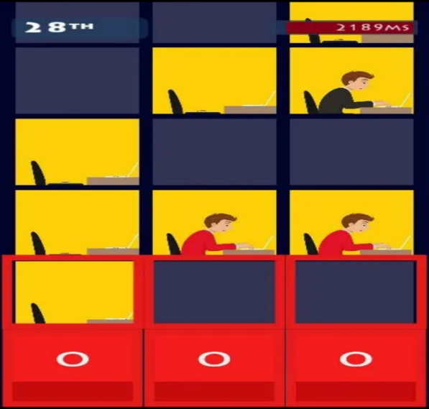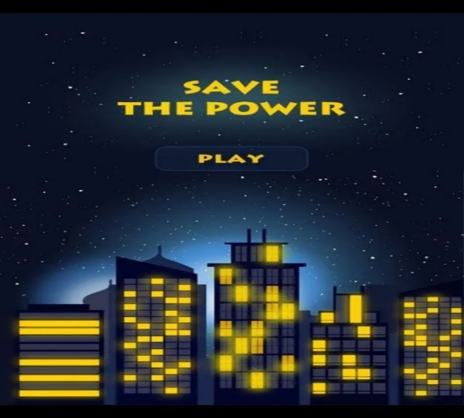

Figure 2 Save the power! (Flavare, 2015)

Figure 1 Save the power! (Flavare, 2015)

## **2.2 Defenders of Nature - Games from YovoGames!**

Defenders of Nature is an android game for children which helps them learn about the importance of nature and how to maintain cleanliness. The game consists of different levels. Each level provides different activities for children which will ultimately benefit the environment.

The game is developed by “Yovogames” for children. It is available on Google Play Store and has 1000+ downloads with 4.5 average ratings from 84 users (Games from Yovogames !, 2018).

It educates children about which environmental waste should go in which rubbish bin for recycling purpose. The game also emphasises on educating the children about gardening activities i.e. removing the dead plants and planting new tress. Providing sufficient water to each tree and flower plant to help them grow. It also teaches children to fix the water leakage system. The game has good theme and interfaces.

However, it has few drawbacks as follows:

1. It doesn’t have score board or reward system or any progressive bar to catch the attention of children to motivate them in playing the game.
2. Not enough animation feedback to help children if they get stuck.

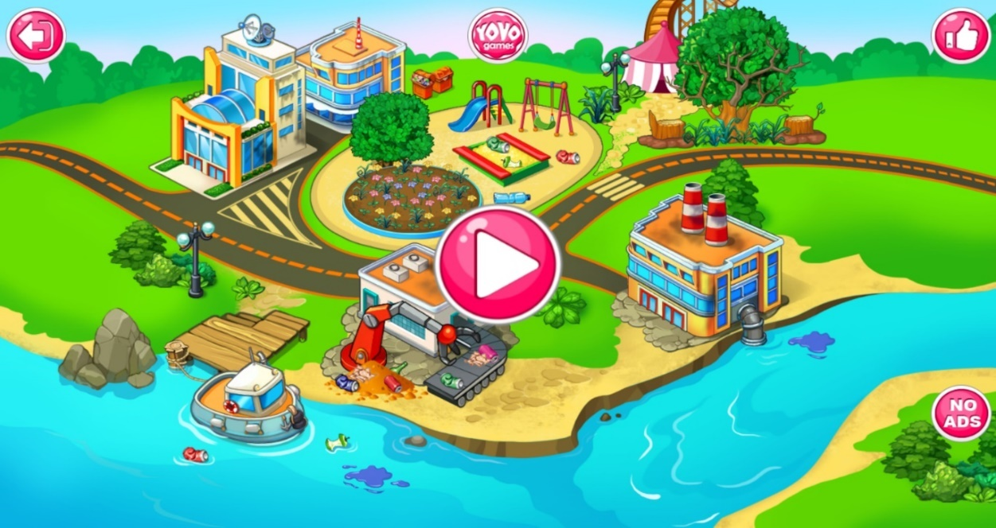

Figure 3 Defender of The Nature (Games from Yovogames !, 2018)

F

## **2.3 Nature Warrior – Akshay Jhadav**

Nature warrior is an android game which is developed to show the importance of maintaining the ecological balance by planting more and more trees around the city. Throughout the game, developer has provided different types of trees that a player will have to plant according to the climatic condition to balance the environment. The developer has also provided a range bar with the help of which player will figure out whether the tree that he/she is planting is proper or not as per the climate. If a player keeps planting a wrong tree, then the game will eventually end.

This game is available on google play store and has a rating of 3.5/5.0 given by 27 users and it has been downloaded 1000+ times (Akshay Jhadav, 2018).

Though the game is giving a good message and helping the player in educating them about the climatic threats we may face if we don’t have sufficient trees around us. But there are several issues with this game:

1. This game is not developed by keeping children in their mind since the speed of game is too fast which may be very difficult for the children.
2. The developer hasn’t provided animation support for the children about which trees should be used in which season.
3. Only 2 seasons provided in the game.

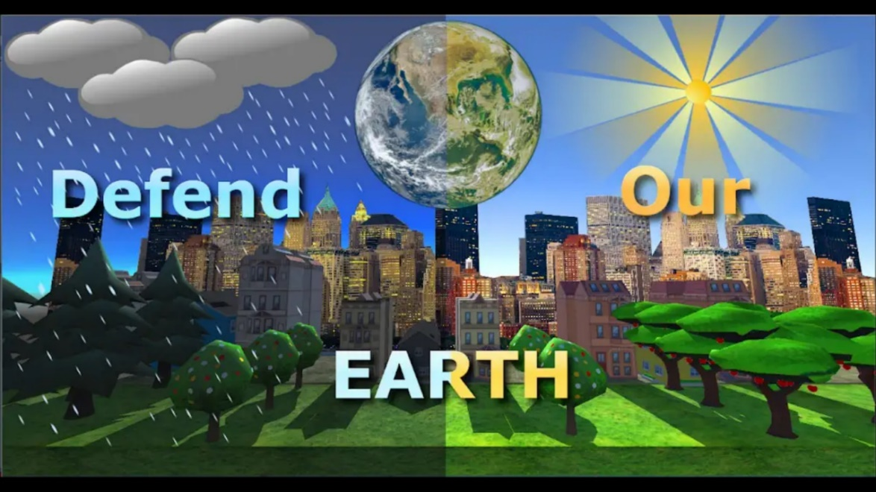

Figure 4 Nature Warrior (Akshay Jhadav, 2018)

## **2.4 Save Water – Warmodroid**

Save water is an android game available on Google Play Store developed by “Warmodroid” for children (Warmodroid, 2015). The game is very simple to play and the idea behind this game is to teach children the importance of saving water. In most countries people face the problem of water shortage due to improper water management system. Saving water during rainy season can be one of solution because the saved water can be reused.

In this game a player must collect water droplets from sky and there is a count meter which shows the score i.e. the amount of water droplets saved in a bucket and the amount of water droplets missed/wasted.

It has a rating of 5.0/5.0 by only 7 users and has been downloaded more than 1000 times (Warmodroid, 2015).

The concept of the game is good, but it lacks several things in terms of gaining the attention of children:

1. It has only one theme.
2. No different levels and scenarios, as there are many ways in which water can be saved.
3. Water droplets in the game falls very quickly which will be difficult for the child to catch them in a bucket and eventually he/she may lose the interest from the game.

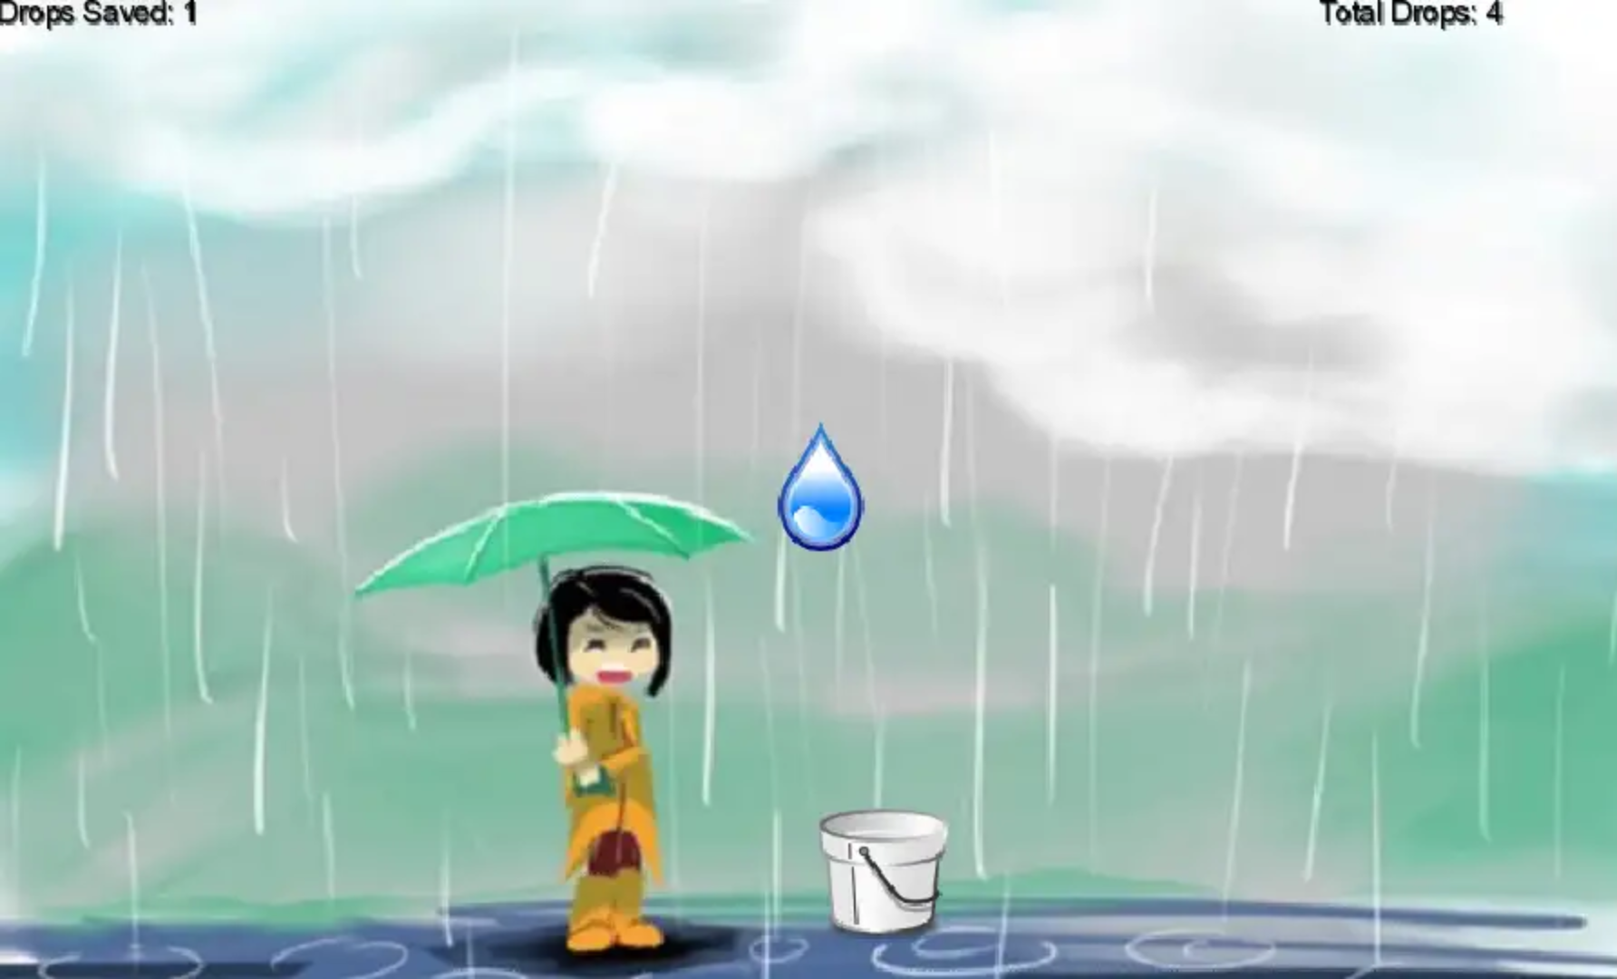

Figure 5 Save Water (Warmodroid, 2015)

## **2.5 Protect the Tree – MoonBear LTD**

Protect the Tree is an android game available in google app store. The idea of this game is to educate children about the importance of saving trees from people who cut them for their benefit which leads to deforestation. Trees are very important for every living being on earth. It helps controlling air pollution. Trees are major contributor in maintaining ecological balance.

The game is being downloaded more than 100k+ times and has an average rating of 3.8/5.0 given by 2k+ users (Moonbear LTD, 2016).

In this game a kid as a player must protect the last tree from group of enemies. To protect the tree, a player is being provided with options of several weapons which he/she can use to fight the enemies. There are several rounds in this game. With each round, enemies keep increasing and once the round is completed, a player is rewarded with coins. A player also earns coins and diamonds by killing the enemies. Coins can be used to purchase lethal weapons. Advance weapons play vital role in killing enemies.

Protect the Trees is a good concept of educating the children about importance of saving trees, but this game has few drawbacks:

1. Due to improper landscape it is difficult for children to place the weapon in right areas for killing the enemies.
2. Theme of the game is very confusing.

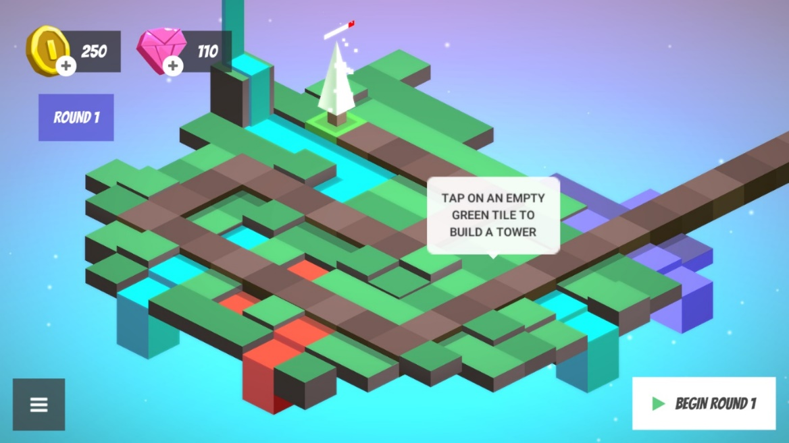

Figure 6 Protect the Tree (Moonbear LTD, 2016)

## **2.6 Garden Games for Kids – Miniclub by Bubadu**

Garden Games for Kids is a game based on a very nice concept of teaching children about how to nurture and save the plants. The plants in return provide us with healthy fruits, vegetables and flowers. It educates children to take proper care of plants by providing sufficient water to help them grow. It teaches children to keep harmful insects away from the plants and to remove dead leaves and dead parts which are of no use.

The game has good visuals for children to keep them interested while playing the game. It also helps children in form of an animation so that they don’t get stuck and confused while playing it. It educates children in placing the gardening tools at right storage areas.

This game is available on google play store and has received a rating of 4.3/5.0 from 8814 users and has been downloaded more than 1 Million times (Miniclub by Bubadu, 2017).

The only flaw this game has is that children may find it difficult to tilt the water pot and seed bag to sow the seeds and water the plants.

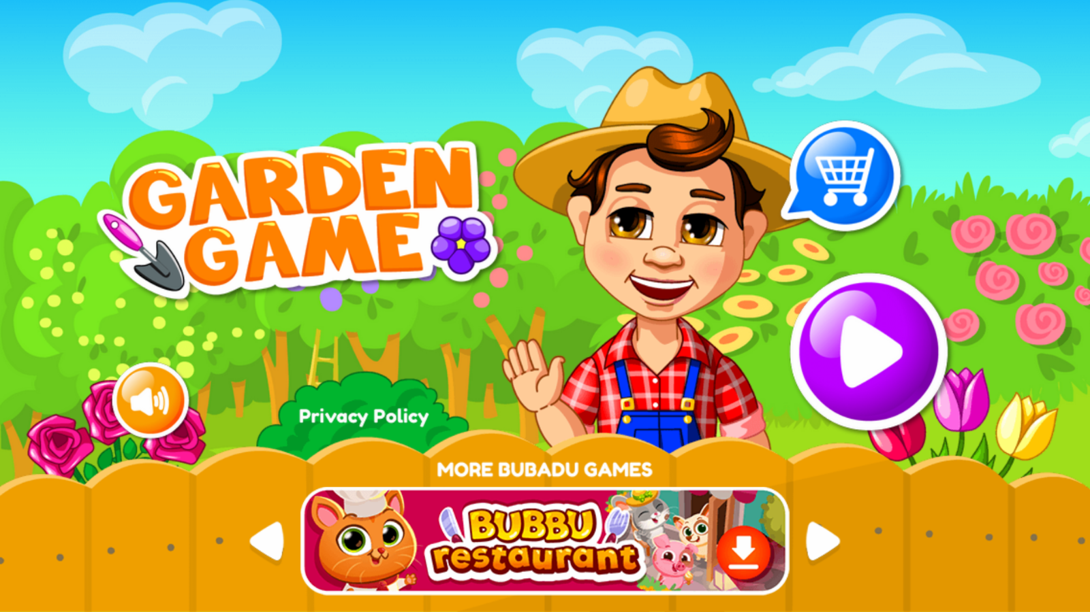

Figure 7 Garden Game for Kids (Miniclub by Bubadu, 2017)

## **2.7 Jungle Doctor – Libii**

Jungle Doctor is an android game developed for children to help the animals that are hurt or in need of immediate help. This game has very attractive visuals for children to keep them engaged in the game.

The game starts with showing a doctor travelling in a jeep to check the health of animals in the jungle to make sure that every animal is safe and out of trouble. The player as a doctor carries medicinal and other kits that he/she may require treating different type of injuries. It provides animation help to the children in form of hint so that they can figure out the next step they have to take. It has an additional feature of taking photo with the animals or any part of the jungle. After saving each animal the player is rewarded with stars. Different animals are used in the game to make it more attractive for children.

The game is available on Google Play Store and has an overall rating 3.9/5.0 given by 5567 users and has been downloaded more than 1M times (Libii, 2014).

It has few negative ratings because we think most of the children find it little tough to use the treatment tools since animation help is not available for some steps. Lastly, the Healing process takes a long time.

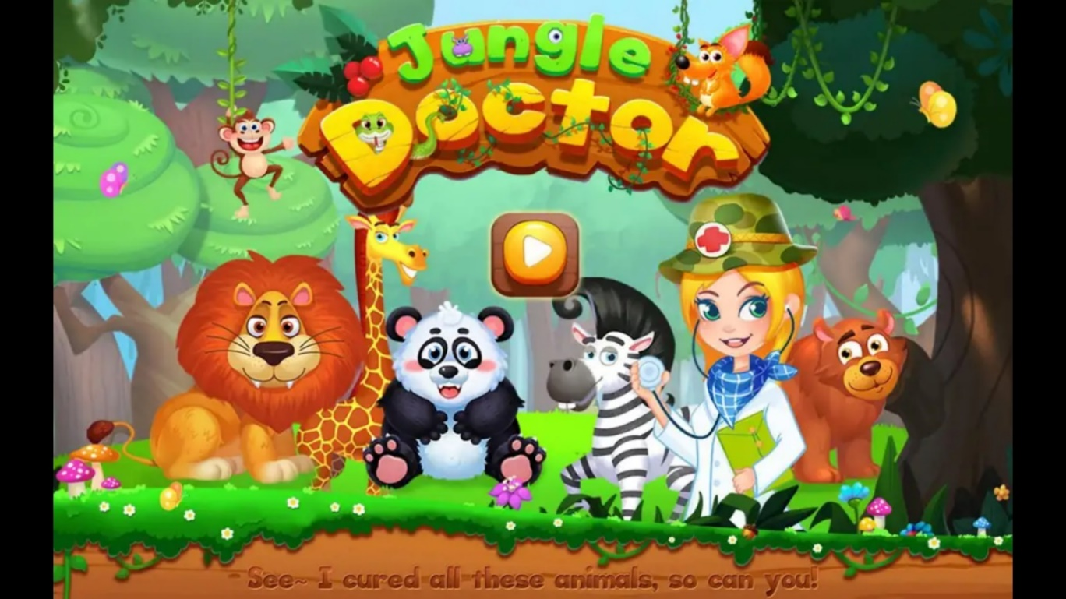

Figure 8 Jungle Doctor (Libii, 2014)

## **2.8 Save Water and Earth - YoguruTechnologies**

Save Water and Earth is a very basic android game for children. It has very simple interface. Through this game, developer wants to convey the message of saving water. In this game a player has to move the water pot in order to collect the water droplets which is very similar to the concept of “Save Water” game reviewed by us. But this game has some additional features like:

1. There is a time limit of 60 seconds, within which a player has to collect maximum drops and can make a high score.
2. A player has to avoid collecting acid drops. Collecting acid drops results in negative scoring.
3. The background image keeps changing to make the game look more attractive for children.
4. It has a good background music.

This game is available on google play store and has received a rating of 4.5/5.0 from 8 users. It has been downloaded more than 500 times (YoguruTechnologies, 2015).

Although, the developer of this game has made a good attempt to engage the children by implementing simple and attractive features, but the game has following drawback:

1. 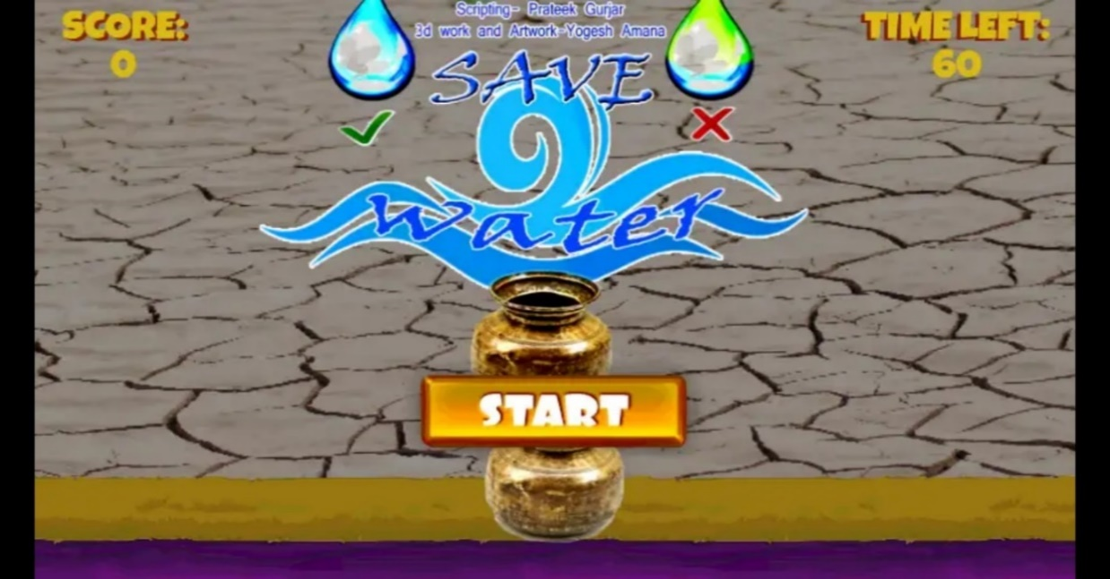Frequently the water drops fall at the edge of the pot and it becomes very difficult to collect those drops.

Figure 9 Save Water and Earth (YoguruTechnologies, 2015)

## **2.9 Comparison Table**

Table 1 - Comparison Table

|  |  |  |  |  |  |  |  |  |
| --- | --- | --- | --- | --- | --- | --- | --- | --- |
| **App No.** | **1** | **2** | **3** | **4** | **5** | **6** | **7** | **8** |
| **Name** | **Save the Power** | **Defenders of Nature** | **Nature Warriors** | **Save Water** | **Protect the Tree** | **Garden Game for Kids** | **Jungle Doctor** | **Save Water and Earth** |
| **Developed By** | **The Flavare** | **Games from YovoGames!** | **Akshay Jhadav** | **Warmodroid** | **MoonBear LTD** | **Miniclub by Bubadu** | **Libii** | **Yoguru**  **Technologies** |
| **Game Type** | **Arcade** | **Educational & Creativity** | **Arcade** | **Eduational** | **Strategy** | **Pretend Play** | **Educational** | **Educational** |
| **Target age group** | **All age group** | **6 - 12** | **N.A.** | **All age group** | **All age group** | **8 & under** | **N.A.** | **All age group** |
| **Rating (1.0 – 5.0)** | **4.7** | **4.5** | **3.5** | **5.0** | **3.8** | **4.3** | **3.9** | **4.5** |
| **Total Reviews** | **23** | **84** | **27** | **7** | **2163** | **8818** | **5567** | **8** |
| **Google play store** | **Yes** | **Yes** | **Yes** | **Yes** | **Yes** | **Yes** | **yes** | **Yes** |
| **Audio** | **Yes** | **Yes** | **Yes** | **Yes** | **Yes** | **Yes** | **Yes** | **Yes** |
| **Visuals** | **Yes** | **Yes** | **Yes** | **Yes** | **Yes** | **Yes** | **Yes** | **Yes** |
| **Reward system** | **No** | **No** | **No** | **No** | **Yes** | **Yes** | **Yes** | **No** |
| **Score board** | **Yes** | **No** | **Yes** | **yes** | **No** | **No** | **No** | **Yes** |
| **2D/3D Style** | **2D** | **2D** | **3D** | **2D** | **3D** | **2D** | **2D** | **3D** |
| **Multiple Levels** | **Yes** | **Yes** | **No** | **No** | **Yes** | **Yes** | **No** | **No** |
| **Animation help** | **No** | **Yes** | **No** | **No** | **No** | **Yes** | **Yes** | **No** |
| **Downloads** | **100+** | **1000+** | **1000+** | **1000+** | **100K+** | **1M+** | **1M+** | **500+** |

## **2.10 Discussion & Conclusion**

Apart from one game we could not find more games similar to our concept of saving electricity. Therefore, for comparison we have gone through other games as well which are not related to saving electricity, but they teach children to save something which is very important for human beings, animals and environment. We thought that we can implement some good ideas from each of the game which will benefit children, be it in terms of good themes and objects that we can include to make our game more interactable and attractive for children.

Out of all the games that we reviewed, Garden Game for Kids and Jungle Doctor are two games that have been downloaded and reviewed by most people. Each of these games have been downloaded more than 1 million times.

“Garden Game for Kids” has received many good feedbacks from parents of the kids who played this game. It consists of good background theme and sound. It greets the children when the game begins. Have several interactable objects. With this game the developer intends to teach kids, how to nurture and take care of the plants which in return provides healthy fruits, plants and vegetables. Throughout the game developer has provided the animation support so that a player should not get stuck. This game also has the highest rating with 4.5/5.0 given by 8821 users. “Jungle Doctor” has many features that can attract the children. This game consists of several wild life animals shown in a cute way to keep the children engaged when the play. It has additional feature of taking snap while playing the game at any stage. It has reward system as well for the children in form of coins. It has received 3.9/5.0 rating from 5570 users. This game has animation support as well but in healing process there isn’t much of the animation help for a player and hence a child might get confused and stuck. Also, healing process takes long time. We believe that because of these two reasons “Jungle Doctor” has received a low rating compare to “Garden Game for Kids”.

Based on the inspiration from these two top level games, we decided to include some features in our game, such as animation support, greeting the children when the game begins, reward system in form of toys instead of coins, cute art style to make our game more appealing for kids.

We carefully reviewed all the games and found that except for few games, most of these games are made for people of all age groups and are non-educational, whereas we are aiming to build an educational game for children between 4-6 years of age. Speed of most of these games are found to be too fast, hence a child might find it difficult to move along with pace of the game. Some games consisted of very few interactive objects and some games don’t even provide animation or any other type of support in their game. “Save the Power!” which is similar to our concept is a non-educational arcade game created by developer only for entertainment purpose. Speed of this game is not suitable for children between 4 – 6 years of age. It includes text as well and have very less interactable objects. Audio of selecting a wrong option in this game could be scary for young children.

We concluded that, along with taking some features from the list of most famous games, we will also include voice support as well for the children to encourage them while playing. Voice support function is not available in detail in any of the game we reviewed. Also, we are intending to use “no text” in our game in order to simplify the experience for children and making it less confusing for them. We believe that by implementing all these important features in our game, we will be successful in conveying our message of “save electricity” to the children.

## **2.11 Summary**

Table 2 - Literature Review: Summary

|  |  |  |
| --- | --- | --- |
| **Name** | **Pros** | **Cons** |
| **Save the Power** | 1. Simple Interface | 1. Game is too fast and not specifically designed for children between 4-6 years of age 2. Less interactable objects 3. Audio of selecting a wrong option could scare children. 4. It includes text |
| **Defenders of Nature** | 1. Different levels 2. Multiple activities for children 3. Good Visuals | 1. No reward system or appreciation for children 2. Not enough animation support for children |
| **Nature Warrior** | 1. Simple Interface | 1. Runs too fast 2. Minimal climatic effects 3. No different levels and scenarios |
| **Save Water** | 1. Have score system 2. Good theme and background | 1. Water droplets falls too quickly 2. No different scenarios or objects 3. No reward system |
| **Protect the Tree** | 1. Different objects used 2. Multiple rounds 3. Uses coins as rewards system. 4. Can purchase new weapons with accumulated coins | 1. Landscape is very confusing |
| **Garden Games for Kids** | 1. Good visuals 2. Good animation support for children 3. Multiple learning outcomes | 1. Difficult to tilt water pot and seed bag |
| **Jungle Doctor** | 1. Good visuals & themes 2. Different animals used to make the game more interactable for children 3. Can take picture in the game at any time | 1. Healing process takes long time 2. Not enough animation support for using treatment tools |
| **Save Water and Earth** | 1. Good background music. 2. Background image keeps changing | 1. Frequently the drops fall on the edge of water pot and it becomes difficult to collect them. |

# **3. Software Methodology: SDLC Spiral Model**

Spiral Model is a type of iterative development style with an emphasis on risk analysis. This Model has 4 phases and for game development it will follow these phases: (SDLC - Spiral Model, n.d)

1. **Design**: In this phase we must get all the requirements needed.
2. **Implement**: In this phase we will implement the design phase we decided.
3. **Playtest**: For playtest we will make sure, what we did is working appropriately and is fun for the player.
4. **Evaluation**: We will evaluate what we did right and what we did wrong, then we will try to improve it by going back to the design phase.

## **3.1 Why Spiral model?**

Spiral model is very flexible especially when it comes to game development. We will have to implement many functionalities into our game and playtesting will be a big factor and that is why we think spiral model is the best. Spiral model is also known to be commonly used in game development. Also, because we have the incremental development style, we can add more things such as levels and additional features even when the game is released or published. This model also provides with other benefits such as quick prototyping, keeping risks low, and allowing changes quickly. (Marco, n.d)

## **3.2 Spiral Model Diagram**

Figure 10 Spiral Model (Marco, n.d)

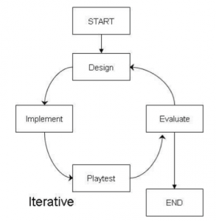

.

## **3.3 How we will use this Model?**

Our first task is to make a basic design of main menu in the game, the main menu will have a Title of game, background Image, Logo or electricity themed image, play button and exit button. The Main menu will be in portrait mode. After that we will implement all the designs and playtest it. During play test we will check to see if our play button starts the first level as intended and also if exit button closes the game app as intended. After the play test of the main menu we will then evaluate everything in that menu and see if we can make improvements to it, whether it’s better art style, image or maybe another button in the main menu.

The second task will be to design level one with all the objects we need. We will then make those objects to be clickable or touchable and it should animate when touched/clicked. We will then test out all the objects in the level, making sure that clicking all objects will play an animation (which is used to give feedback to the player that the object has been touched or clicked) and then lastly, we will evaluate it. During evaluation we will check how we could make the animation better when clicking on objects and we could even add extra effects to our animations for a more appealing interaction with the object.

Third task will be to design and implement an icon on the top left corner to go back to the main menu. When we implement it, the player should be taken back to the main menu of the game. We will test several times by going from main menu to in-game and then from the in-game level to the main menu by pressing the home menu icon on the top left corner of the screen. We will evaluate this implementation and see if we can make it better with help of animations or things like loading screen etc.

Fourth task will be to implement an audio voice at the start of the level, this audio will be used to communicate the objective of the level, for example when the level starts, there will be a voice explaining the scenario like “It is a bright and sunny day, mom and dad left for work and gave us the job to turn off all the electronics that are wasting power. Can you find what is wasting power?” and so a voice assistant like this will be used in the beginning of every level. After the implementation we will test the game at least 3 times from menu to start the game and check if the audio plays at the beginning of the level. After testing we will evaluate the audio, whether it is a good structured dialogue for kids with a nice friendly tone and if it needs an improvement we will implement it again with the improvements.

Fifth task is to design and implement a progress bar, the progress bar will be used when the player selects the correct object, and if it’s a correct object the progress bar will keep on filling till its maxed. We will then test it by selecting each object, correct objects should fill the bar a bit and incorrect object should not affect the progress bar (we will use failure interface for the incorrect objects). After testing it 3 times at least we will then evaluate what we have so far and see where we can make improvements.

The sixth task will be to continue where we left off after the fifth task, we will now make sure that once our progress bar is full, the player should be shown a “level complete” screen and proceed to the next level. After designing and implementation, we will test these out by trying it at least 3 times and afterwards we will evaluate to see what we did right and what we did wrong. If we need improvements, we will design and implement it again with the improvements.

Seventh task is it design and implement a simple UI for failed attempts which will be used to display a maximum of 3 crosses or X’s, if the player gets 3 X’s then the level should restart all over again. We will need to test this one out carefully as it might break the whole game, so we will test this one for at least 3 times to see if everything is working as intended. When the player clicks an incorrect object, one X should be added to the top right corner, and if the player gets all 3 then restart the level. We will evaluate this as the last phase and see what we did right and where we could improve.

After implementing all the core functionalities mentioned from first task to seventh task, we can start designing and implementing different levels that have different scenario and challenges with the core functionalities already worked on. We can use the same functionalities from level 1 and implement in on to level 2 and other levels very easily since we have tested it all out one by one.

# **4. Game Design & Analysis**

In this section we will discuss and roughly show our design sketches, interfaces and some example to represent what we are aiming for. We have also included flowchart, use case and navigation diagrams to represent the functionalities of our planned game.

## **4.1 Game Menu**



Figure 11 Design Sketch - Game Menu

Since we are developing an educational game for children between 4 to 6 years old, we thought that we should make our game menu simple and effective. Our game menu will have a title which is the only exception we will make because every game needs a title and we plan not to use any text in our game so that children won’t get overwhelmed by texts and are unable to read. The play and exit button will use an image instead and not a text-based button. The menu will also contain a background music and art style to be more pleasing. The screen itself will be in portrait mode for the menu, we don’t think it would make much difference regardless of portrait mode or landscape mode since it is a main menu, but we think that portrait mode will be a little bit more user friendly since people hold their phone as if they are using portrait mode.

## **4.2 PLAY GAME – LEVEL 1**



Figure 12 Design Sketch - Play Game Level 1

Our main functionalities will be used when the level starts. Every level will have its own art style, scenario and objects. Beginning of the level a voice assistant will be used to communicate the objective of the game and give feedback to the player whenever they touch an object. We have the main menu icon in the top left corner which will take the player back to main menu. The fail or attempt indicator on the top right corner will keep track of player’s incorrect choices, if player gets 3 strikes on the attempts then the level will start automatically, and it will be shown in form of a cross or X as it is appropriate design for fails and attempts. The lower progress bar in the bottom centre will indicate the progress of a player and every time they click the correct object; the progress bar will fill bit by bit until it is maxed out which will lead to level completion and advances the player to the next level.

Each level will also have a different art and object placement. All objects will be interact-able so when the player touches the object, the object should animate as a visual feedback to let player know that object has been touched. There will be correct objects and incorrect objects based on the level and the scenario presented to the player. We will also add some sparkle or shiny effect on top of all the objects to indicate that these objects are interact-able, this will attract children to the shiny or sparkle effect which will get them to touch the object and then with the help of voice feedback they will automatically discover how to play the game and what they should be doing. Lastly the levels will be locked in landscape mode which is the most appropriate for our game as we will need the space for the art style and objects placed in the level.

## **4.3 Example 1 preview**

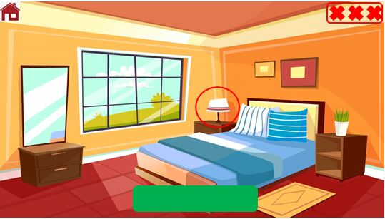

Figure 13 Bedroom - Daytime Art (Vectorpouch, n.d)

## **4.4 Example 2 Preview**

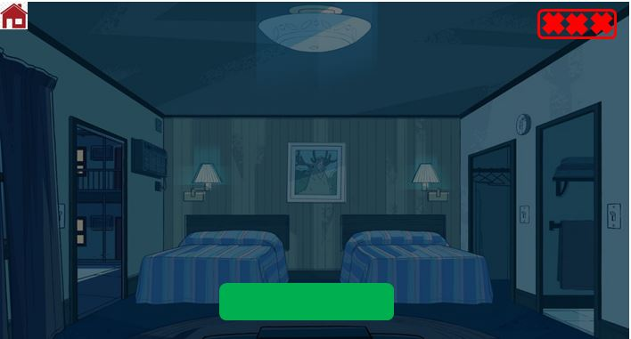

Figure 14 Bedroom - Night (Andrey, n.d)

## **4.5 TOUCH INTERACTION FLOWCHART**

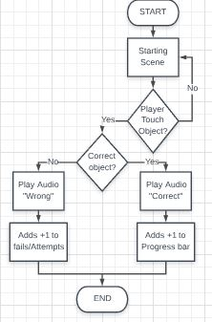

Figure 15 Flowchart - Touch Interaction

## **4.6 PROGRESSING LEVEL FLOWCHART**

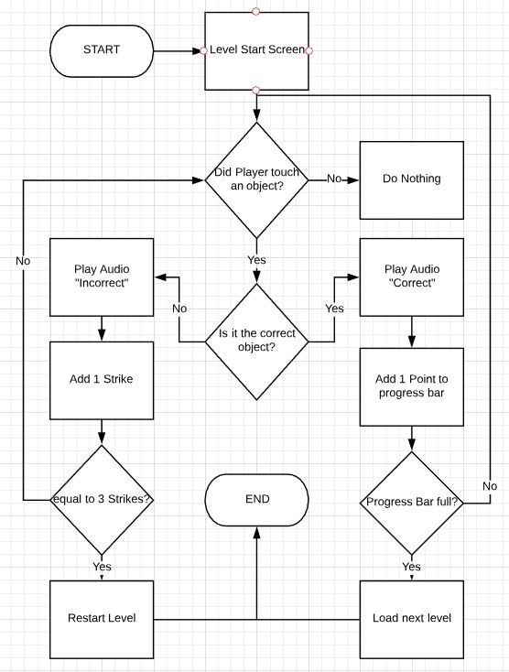

Figure 16 Flowchart - Progressing level

## **4.7 Overview Flowchart**

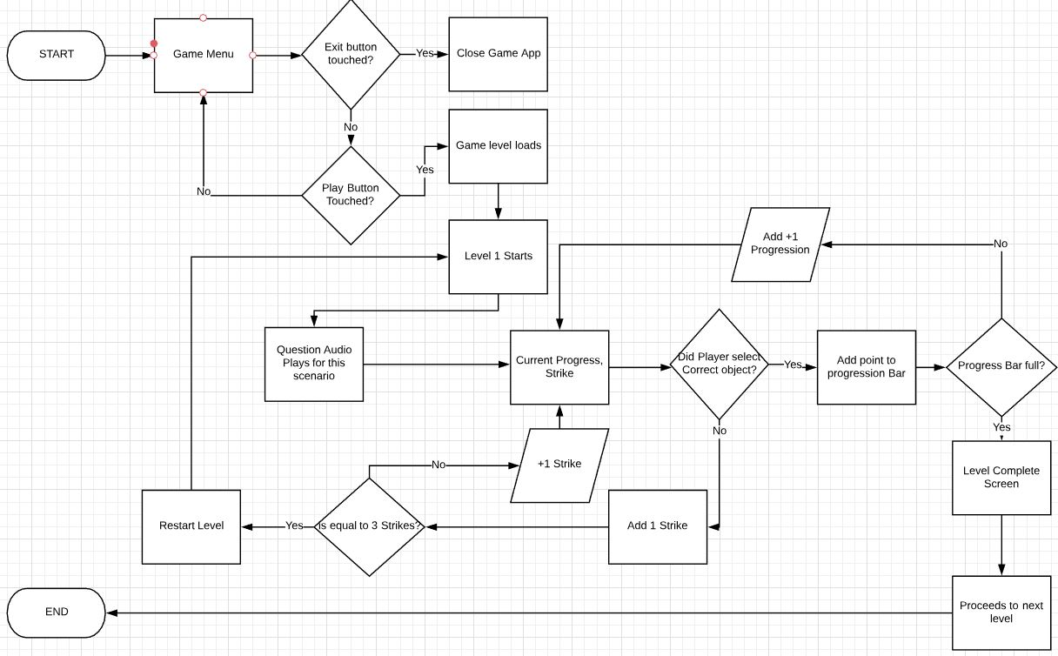

Figure 17 Flowchart - Overview

## **4.8 USE CASE**

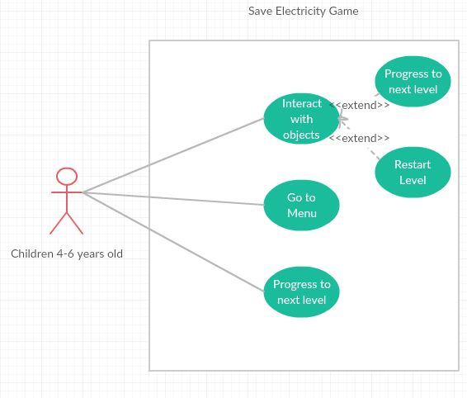

Figure 18 Use Case - Children Interaction

## **4.9 OVERALL NAVIGATION**

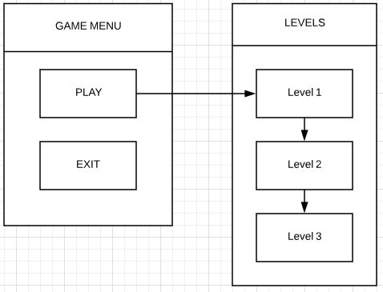

Figure 19 Overall Navigation

# **5. Resources Collections**

In this section we have mentioned what resources we will be needing and will be using for our project. Our project will require many software for the game development and a few hardware stuffs also.

## **5.1 Software**

### **5.1.1 Unity & Unity’s asset Store**

Unity is a free game developing software, it is very popular and contains a lot of resources and materials for game developers such as artwork, animations, models, and many more things in the unity store. There are many free assets too and the ones which are not free have reasonable and cheap pricing.

We will be using Unity to develop our android game. The Unity game engine uses C# programming language which I, Kunal Prakash as the developer am comfortable with and more used to. It will also help with obtaining assets that will be needed for our game development. There are also additional nice features with unity such as you can use visual studio with it when coding.

### **5.1.2 Android Studio**

Android studio is software made for developing android apps and has additional useful tools such as android phone emulation. Although we won’t be using android studio for developing a game, it still might be useful for running the game on Android Studio’s emulation feature so that we can test the game out.

### **5.1.3 Visual Studio**

Visual studio is also very popular IDE (Integrated development environment) for developers and can be used for many things such as web development, computer programs, web apps, web services and even mobile apps. We will mainly use visual studio for coding and its Intelligence feature that helps with coding. (Microsoft Visual Studio, 2018)

### **5.1.4 Unreal Engine’s asset store**

Unreal Engine is also similar popular game development software as Unity, it is the competitor of Unity and is also free. The reason for selecting Unreal engine even though we already have Unity as our game development software, we can get assets from the Unreal asset store which will mean that we will have plenty of resources available when developing the game. So, if there’s something we are looking for such as artwork in the unity asset store and we cannot find it, we could always search the Unreal asset store to see if they have something we like.

### **5.1.5 Office 365**

We will be using Microsoft software such as word, excel, PowerPoint for things such as documentation, presentation and creating graphs. All the provided software will be very important for us as we will be relying on it a lot and will be one of the most commonly used software throughout our project.

### **5.1.6 WhatsApp**

WhatsApp is one of the many ways we communicate between each other. We also use WhatsApp for sharing files together.

### **5.1.7 Adobe Photoshop**

Photoshop is a popular software used for imaging and graphic design. (Photoshop - Reimagine reality, n.d) This can help us with designing our own art or combining multiple arts together. It is a very handy tool and since we are building an android game, the art or visual will play a big role during our planning and design.

### **5.1.8 GitHub**

GitHub is a very popular website for developers to share and work on a project together. The website will be used to upload our files, share files and update each other’s files whenever we can. This will provide us some flexibility in working together in a nicely organized manner.

### **5.1.9 Stack overflow website**

Stack Overflow is a very handy and popular website for developers all around the world. You can answer or ask questions relating to development and coding. This will be very handy for us as we will require assistance from time to time if we come across any errors, so this website will help us in finding solutions to our problems during development.

## **5.2 Hardware**

### **5.2.1 PC Desktop**

We will be using PC desktop to run all the software that will be required when developing the game. The desktop is fast enough to run everything efficiently without any problem. Desktop is also used for communication and researching.

### **5.2.2 Android Mobile Device**

A cheap android device will be used for testing purposes only. It will play an important role in testing when we try different functionalities and will help us debug problems/errors.

### **5.2.3 Flash-drive/USB storage device**

We will need to backup different versions of our game development as we progress throughout the development. This will ensure we have working versions to fall back to if we come across any situation that might ruin or destroy our game file.

# **6. Project Risks**

Our project will contain many risks and we will identify these risks and try to manage it to make sure everything goes smoothly and that our game’s quality is good.

## **6.1 Eight Weeks Deadline Time**

We are given 8 weeks to complete our project. This can be very challenging task for us as there are some time-consuming factors. Things such as testing, debugging and fixing errors will consume a lot of time. Same goes for researching; researching can also sometimes take a long time to find the relevant information or resources that will help us in our project.

## **6.2 Amateur Game developer**

I (Kunal) am new to game development, this project being the second game I would need to work on and the first time developing a game specifically designed for android with 2D style. Many things such as unity software and unreal engine are relatively new to me. Overall game development is a learning experience as well so there will be many issues regarding the development. There is also a risk in implementing certain functionalities, due to lack of game development experience and I will need to decide that I do not select a functionality that is too complex and out of my understanding or skillset.

## **6.3 Time Management/Scheduling**

Both I (Kunal) and Suraj have different time schedules and availability due to different lecture or work timings. So, arranging meetings can be a little bit of a challenge for us.

## **6.4 Finding assets for the game**

Our project will be heavily reliant on game assets, both during game development and before game development starts. When it comes to mobile game development in the education category for kids, you won’t find many assets and examples that will help you develop an educational game for kids. Artwork, animations, characters and many more things will be needed to develop our game which should also be suitable for children so finding these assets can be a challenge and a risk if we are not able to get what we need.

# **REFERENCES**

Akshay Jhadav. (2018, Jan 24). *Nature Warrior*. Retrieved from Google Play: https://play.google.com/store/apps/details?id=com.AJSkland.Naturewarrior

Andrey. (n.d, n.d n.d). *Chat-night background.png*. Retrieved from Steven universe wiki: http://steven-universe.wikia.com/wiki/File:Chat-night_background.png

Flavare, T. (2015, April 1). *Save the Power!* Retrieved from Google Play: https://play.google.com/store/apps/details?id=com.theflavare.savethepower

Games from Yovogames ! (2018, May 05). *Defender of the nature*. Retrieved from Google Play: https://play.google.com/store/apps/details?id=com.YovoGames.Defender

Libii. (2014, Dec 31). *Jungle Doctor*. Retrieved from Google Play: https://play.google.com/store/apps/details?id=com.libiitech.jungledoctor

Marco. (n.d, n.d n.d). *Spiral Model For Game Development: Techniques To Develop Games*. Retrieved from gamedevelopertips: http://gamedevelopertips.com/spiral-model-for-game-development/

*Microsoft Visual Studio*. (2018, October 24). Retrieved from Wikipedia: https://en.wikipedia.org/wiki/Microsoft_Visual_Studio

Miniclub by Bubadu. (2017, March 14). *Garden Game for Kids*. Retrieved from Google Play: https://play.google.com/store/apps/details?id=com.bubadu.gardenkids

Moonbear LTD. (2016, Oct 19). *Protect the Tree*. Retrieved from Google Play: https://play.google.com/store/apps/details?id=com.MoonBear.ProtectTheTree

*Photoshop - Reimagine reality*. (n.d, n.d n.d). Retrieved from Adobe: https://www.adobe.com/nz/products/photoshop.html

*SDLC - Spiral Model*. (n.d, n.d n.d). Retrieved from tutorialspoint: https://www.tutorialspoint.com/sdlc/sdlc_spiral_model.htm

Vectorpouch. (n.d, n.d n.d). *Cartoon bedroom interior background template*. Retrieved from freepik: https://www.freepik.com/free-vector/cartoon-bedroom-interior-background-template-cozy-modern-house-room-in-morning-light_2238484.htm

Warmodroid. (2015, Nov 30). *Save Water*. Retrieved from Google Play: https://play.google.com/store/apps/details?id=mohit.warmodroid.game.android

YoguruTechnologies. (2015, Feb 25). *Save Water and Earth*. Retrieved from Google Play: https://play.google.com/store/apps/details?id=com.Yogi.AmanaSavewater

# **Responsibilities**

Figure 20 Current Progress & Responsibilities

# **Gantt Chart – Work Breakdown Structure**

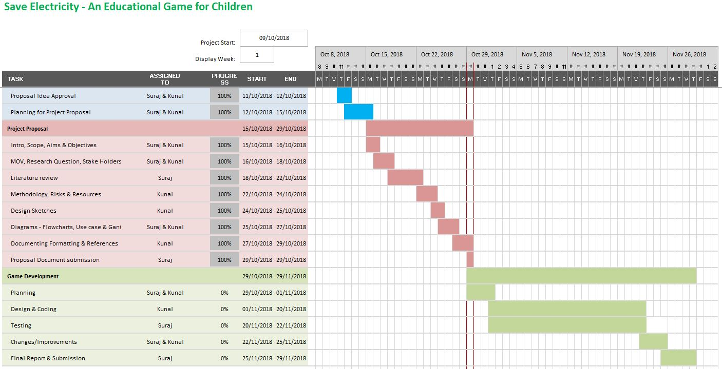

Figure 21 Gantt Chart - Work Breakdown Structure